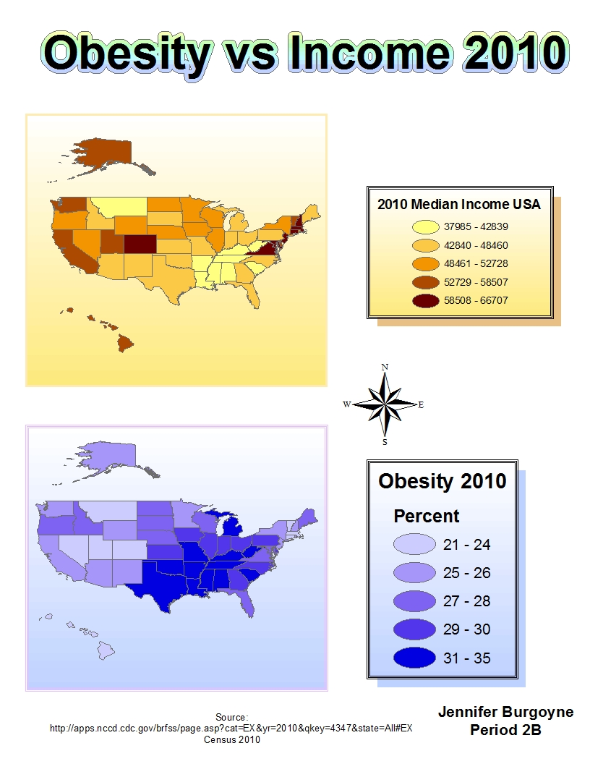
Write a 250 word analysis describing the relationship between the two variables. Is there a relationship between these variables? Use specific geographic references. Why do you think a relationship exists?
There is a relationship between median income in states and obesity percentages throughout the United States, but not all states strictly follow this relationship. Most states with a higher median income have lower obesity percentages, and states with lower median income have higher obesity percentages. For example, many Southern states, such as Louisiana, Alabama, and Georgia, have low median income levels, and high obesity percentages. Some states in New England, such as New Hampshire, Connecticut, and Massachusetts, have high median income levels, and low obesity percentages. Colorado has very high median income, and very low obesity levels. However, other states do not follow this rule. Montana has low median income and low obesity levels. When people receive lower income, they are more likely to eat at cheap and unhealthy fast food restaurants, such as McDonalds and Burger King. These fast food restaurants sell food that lack nutrients, and have too much sodium, carbs, fats and others. This leads to people being very unhealthy. They don’t receive the right proteins, vitamins, and so forth. Instead, they consume too much of things that they don’t need. Intake of these things, such as sugar, leads to a higher chance of diseases like diabetes. There is an abundance of these fast food restaurants, especially in places with people who receive low income. People with high income are able to buy healthy produce and fresh foods. They do not need to go to fast food restaurants very often, so they can life healthier and are generally not as obese.

