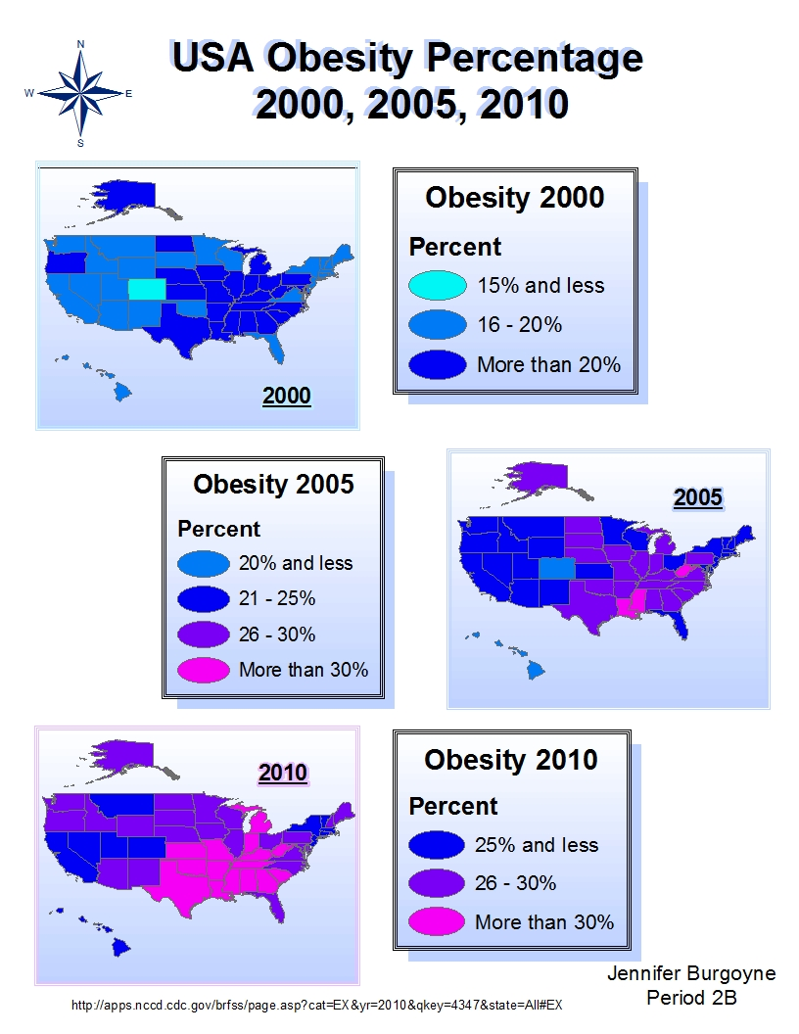

- How do the overall percentages change throughout the years?
Overall percentages increase throughout the years.

- Describe the changes in the states and percentages.
Obesity rates between states stay relatively similar. For example, obesity in Hawaii and Colorado remain low in relation to other states throughout the years. The South has particularly high obesity percentages.

- Now that we know, what should we do about it? How can we use this info to make changes?
We should teach and inform people in the South about what’s healthy and what isn’t. The government should support having health classes in schools and should teach people about making healthy choices through TV or other things. People all over the US should also learn that obesity rates are rising. They should learn the health risks of obesity.

